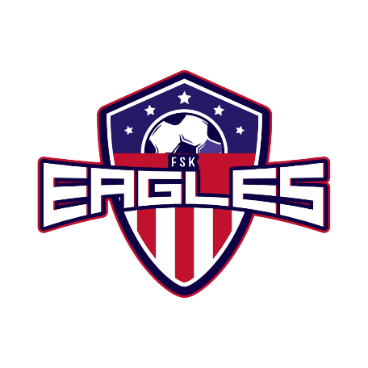
Join Our Winning Team!
Youth Sports Sponsorship Program
Sponsorship Commitment Form
2024 Fall Season

Soccer is the world’s most popular and participated in sport. Perhaps even your own children have played and experienced the love, skill, and value of playing this sport. Our goal is to provide a place for each child to learn, love and grow in a fun, challenging and educational environment. Our Youth Sports Sponsorship Program is an avenue for local businesses to make a positive difference in the promotion of recreational soccer in our community. The support received through this sponsorship assists us in keeping our program fees at a nominal level.

FSK Jr Eagles Soccer League services over 600 players between our fall and Spring Seasons! For us to cover the programs extra costs (scholarships, equipment, awards, field maintenance, etc.), our policy of “nominal cost participation fees” would be greatly affected without your support. Our program strives to teach not only soccer skills, but life skills and life lessons as well. Here are some ways your donation could help:
- $150.00 ensures a scholarship child can play soccer this season!
- $180.00 can buy a set of Soccer Balls for a team!
- $200.00 can buy 1 set of corner flags for Game Days!
- $350.00 can buy 1 set of nets for the goals!
We fully realize that you are frequently approached to contribute money for many other worthwhile causes and programs. Please consider helping to keep youth soccer in our community!

Company Recognition and Exposure
Sponsorship also provides advertising exposure for your company at our soccer fields.
Additionally, we thank all of our sponsors on our Website & Facebook Page.
Red Sponsorship = Wil display provided signage at RMP Snack Shack!
White Sponsorship = Banner Displayed on light poles at RMP!
Blue Sponsorship = Logo on Sleeve of In-House Team Jersey!
Eagle Pride Sponsorship= Both Banner and Logo on All URSL Uniforms!
For more information, contact us at fskjreaglessocer@gmail.com!

*To be included on a jersey, payment & logo needs to be received by June 30th, 2024*
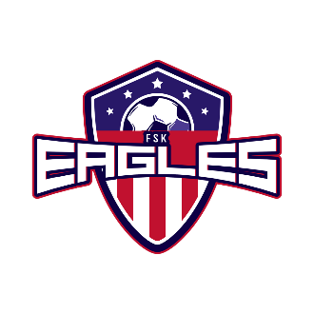

Sponsorship Donation Level

Red - $200 White - $500 Blue - $750 Eagle Pride - $1000 Other Amount - $______

Name_____________________________________________ Phone # _________________________

Business Name_________________________________________________________________________

Address_______________________________________________________________________________
1.Please return the bottom of this sponsorship form with your enclosed check. 2. Please Email camera ready art of your logo for printing to fskjreaglessoccer@gmail.com 3. Make checks payable to FSK Jr Eagles Soccer 4. Mail to FSK Jr Eagles Soccer League PO Box 196 Taneytown MD 21787 or return to Kyle Myers

